**RESUME**

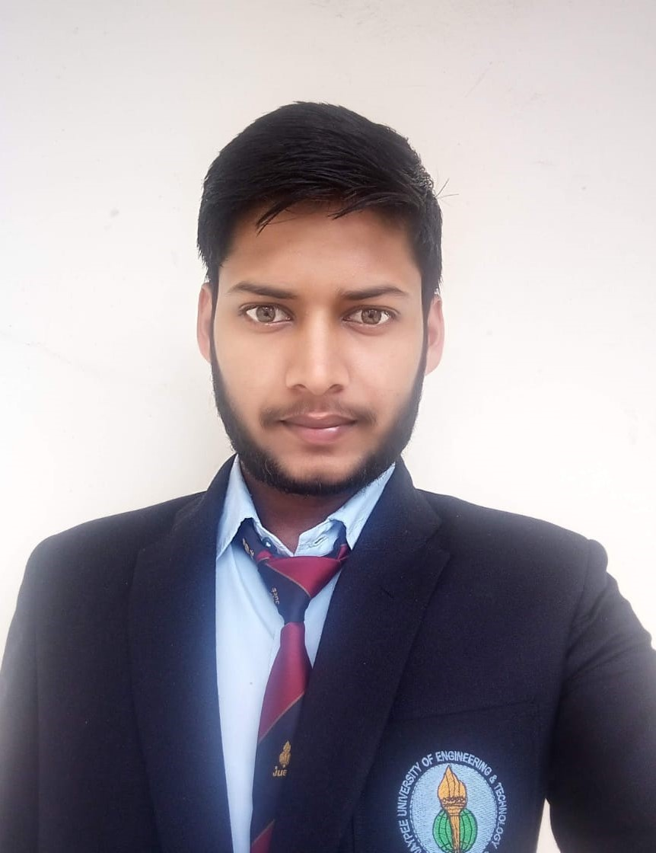

Photo

**Aditya Kumar**

Jaypee University of Engineering and Technology

Raghogarh, Guna,

M. P.-473226, India

**Phone:**8840532421

**Email:**[adityakumar27200@gmail.com](mailto:adityakumar27200@gmail.com)

**Objective**

**To work for an It company which provides the opportunity to improve my skills and knowledge to grow along with the organization objective.**

**Education Qualification**

|  |  |  |  |  |
| --- | --- | --- | --- | --- |
| **Year(s)** | **Qualification-Degree/Diploma** | **Board** | **College/Institute** | **Percentage/CGPA** |
| 2015 | 10th | UP, Board | G.S.A.S. Academy Harraiya – Basti (UP) | 86.83% |
| 2015-2017 | 12th | UP, Board | G.S.A.S. Academy Harraiya – Basti (UP) | 74.46% |
| 2018-Present | B. Tech. | JUET | JUET Guna ( MP) | 7.1 CGPA |

**Projects**

**Machine Learning :**

* House price prediction using Boston Dataset
* Hand written digit classification using Mnist Dataset

**Cirtification**

Python ,

Aplied Machine Learning in python

**Technical Skills**

**Language:** Python ,C++

**Developer Tools :** Machine learnig

**Personal Details**

**DOB : 02/07/2000**

**Gender:**Male

**Language Known:** English & Hindi

**Address:**Bishesharganj,Distt-Basti, Utter Pradesh, INDIA

**Declaration**

I declare that the details above are correct and true to the best of my knowledge.

**Place: Guna**

**Date:31/06/2019**  **( Aditya Kumar)**